Week 3 Day 1 Participation Submission Screen Shots

Hector Cardona Alvarez
College of Business, Westcliff University
WEB 601 Front-End Web Development
Week 3 – Day 1
Professor Dr. Wissam Ahmed
July 14, 2026

Var NOON
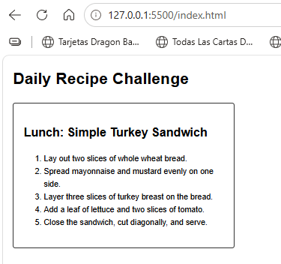

Var SUNSET
